Inserting Running Head: The MS Office Version
CASS Tutoring Center
Lincoln University

Here are some tips for starting running headers on your own paper!
- Open a new document.
- Click Insert tab and click Page Number drop down.

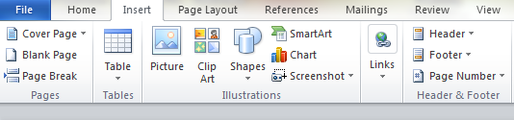

- Choose “Top of Page” and then “Plain Number 3”.
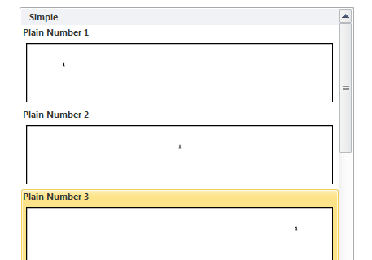

- After you do this, a Design tab opens. In the Design tab, you have to check the box for
□ Different First Page
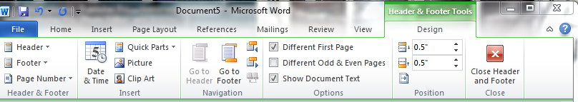
- Type Running head: TITLE & then tab over to right margin and type 1.
- Double click into the body of the page to get out of headers.
Tips for starting running headers cont’d…

- Type your cover page information, which is the Title, Your Name, and Your School.
- Insert a page break or space down to second page of your paper.
- On the second page, double click on the page number 2.
- Place your mouse cursor in front of 2 and type your TITLE.

- You will have to tab until TITLE is on left margin and page number is on right margin.
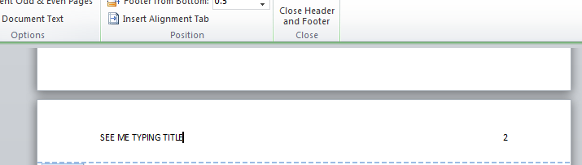

The End!

