Introduction
Since the advent of Internet in 1995, there are many social networking sites that we can use to connect with our friends, family members, colleagues, and even strangers who share the same interests or activities. We can use such sites to send e-mails to connect with friends, share information on any topics, conduct instant messaging and videoconferencing, and even share ideas and events with people we have never met. As of today, there are more than 200 active social networking sites on the Internet.
Social Networking Sites
Figure 1 shows the top 10 social networking Web sites as of February 2011. As illustrated, Facebook leads the way with 64.32% of the market share. Rounding up the top three choices are YouTube, with a market share of 19.22%, and Myspace with a small 1.67%.
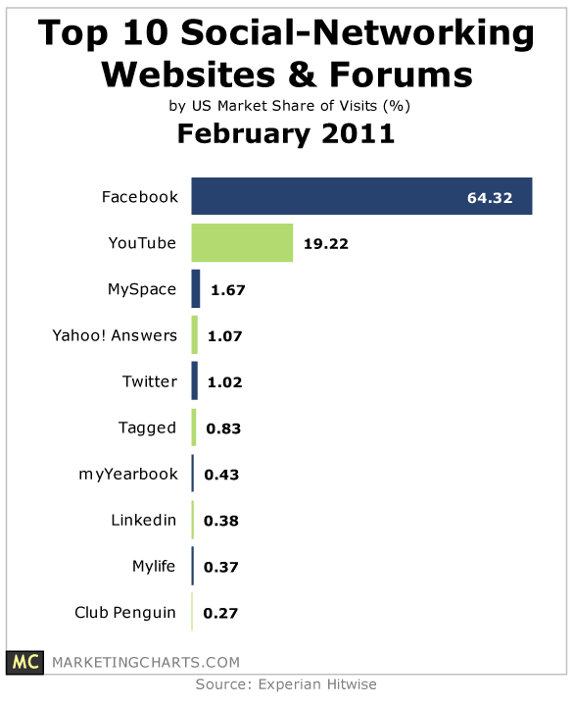
Facebook
Officially launched in February 2004, Facebook was founded by four computer science students from Harvard University in late 2003: Mark Zuckerberg Eduardo Saverin, Dustin Moskovitz and Chris Hughes. The initial idea for Facebook was to allow students share photos and notes. Today, there are more than 750 million Facebook active users around the world, and earned an estimated revenue of $2 billion in 2010. Although Facebook has established a 13-year-old minimum age requirement, there are many underage children owning accounts on Facebook.
YouTube
In February 2005, three former PayPal employees living in San Bruno, California, utilized the Adobe Flash Video and HTML5 technology to create a video-sharing Web site. The name of their new business is YouTube, LLC. Individual users can post video clips, movie clips, TV clips, and music videos for public viewing, but recently major media corporations such as CBS, BBC, and Hulu have started to post their video contents to YouTube too. YouTube was sold to Google, Inc. in late 2006 for US$1.65 billion.
Myspace
Myspace was founded in August 2003 by several eUniverse employees, and is currently located in Bevely Hills, California. In June 2006 through 2008, Myspace was considered the most popular social networking site in US. However, it was overtaken in April 2008 by Facebook. Today, Myspace has 50 million users around the world, is available in 15 languages, and earned an estimated revenue of $385 million in 2009.

Twitter
Twitter is a microblogging Web site, allowing users to send and receive text-based posts of fewer than 140 characters, called tweets, to anyone around the world. This social networking service is based in San Francisco. It was initially incorporated in California but was incorporated in Delaware as of this year. Twitter was founded by Jack Dorsey in March 2006 and was officially launched four months later. Today, it has an estimated 200 million users worldwide, and handled over 1.6 billion searches per day.
Benefits of Social Networking
Social networking sites allow users to experience real-time interaction with other users from all over the world. For instance, Twitter allows users to post photos and let their friends know, up to the minute, where they are and what they are doing. Corporations have also used social networking sites to test-market and promote their products, gather feedback from consumers, and to build brand awareness. A recent study revealed that biotechnology companies are using social networking sites to share and exchange scientific knowledge. Even in academia, teachers and professors are using the latest technology to connect with their students outside the classroom, to post assignments, and to conduct discussion forums.
Downsides of Social Networking
Unfortunately, one of the major downsides with social networking sites is loss of privacy. Innocent users, especially young children and teenagers, might give out too much personal information to the wrong people. Sexual predators often scour the Internet for these young victims. Older users may also unintentionally disclose medical and financial information on the Internet that might one day be stolen from them. Online bullying, also called cyber-bullying, has become a daily occurrence and can sometimes resulted in deadly consequences.

